Cyngor Cymuned Carreghofa Community Council

Minutes of the Meeting held on Tuesday 29th July 2025
at Llanymynech Village Hall

PLEASE NOTE THAT THESE MINUTES ARE DRAFT UNTIL RATIFIED BY THE COMMUNITY COUNCIL AT ITS MEETING ON 30th SEPTEMBER 2025

Present:
Cllr I Parry (Chair)
Cllr J Fynes
Cllr C Hall
Cllr. F James
Cllr C Jones
Cllr C Savage
Cllr. I Done

In attendance:
Mr. M . Donkin Clerk to the Council
Mr M. Welsby Project Manager, Keir (for Item 7.1.)
Mr. Mustafa Al-deerawi Project Manager Canal & Rivers Trust
Cllr A. Bond: Chair – Llanymynech & Pant Parish Council

1 Apologies for absence

Cllr R Dover

2. To record Declarations of Interest in items on the agenda

None

3. To confirm the minutes of the meeting held on Tuesday 24th June 2025

The minutes of the meeting held on 24th June 2025 were amended as follows:
‘Item 8.3. Delete Cllr Savage; insert Cllr Jones. ‘
With this amendment the minutes were agreed as a correct record. Proposed by Cllr Fynes, seconded by Cllr Hall and approved unanimously.

4. Matters arising from the minutes

4.1. Ref: item 4.2. Visit of the Swiss Ambassador
The Chairman reported that the visit of the Swiss Ambassador had been a great success. Cllr Fynes added that the event had been reported in the national press.

4.2. Ref: item 7.4. Canal Wharf
Cllr Fynes said that he had spoken to the owners of Rose Cottage who had no objection to a winding hole being reinstated on the canal beside their property. They felt that this would not be an issue.

5 Finance
5.1. Current position
The clerk had circulated papers which confirmed that the Council’s accounts as at Thursday 24th July 2025 were as follows: -
Deposit account: £8223.21
Current account: £906.41
Pension account £76.17

5.2 First Quarter Financial Statement
Council noted the First Quarter Financial Statement as set out in the papers for the meeting. The Clerk said that income had exceeded expenditure in the quarter but , nonetheless, prudence was needed. He felt that with care, the budget would come in on target or underspent at the year end.

The Clerk offered to take questions. There were none. The proposal that the Financial Statement be accepted was put by Cllr Fynes, seconded by Cllr Done and agreed unanimously.

5.3. Clerk’s Salary. Award
Council noted the communication from the National Association of Local Councils informing local authorities of the Local Government Pay Agreement 2025 / 26. The award is to be backdated to April 2025. In answer to a question from Cllr Fynes, the Clerk said that the increase had been anticipated when the budget was set and that funds were available to meet the award.

Cllr Fynes then proposed that the award be agreed. This was seconded by Cllr Hall and passed unanimously.

Approval of Payments
Approval was sought for the following payment as listed in the papers for the meeting: -

- M.I. & T. E. M. Pritchard – Grounds maintenance contract 2nd quarter - £966.00
- Llanymynech Village Hall - Rent for April meeting - £24.00
- TEEC Ltd - 12 months website hosting including all standard TEEC security features and services plus Transfer of Domain and Automatic Planning Feature - £583.19 The Clerk pointed out that TEEC had charged for the transfer of the Domain Name in the previous year and it was agreed that he should contact TEEC to clarify whether this should be paid again this year.
ACTION: Clerk

Payment of the above items was approved.

6. Planning

6.1. Planning Application at Wern
Historic Environment (Wales) Act 2023 Consultation Application Reference: 25/0929/LBC Grid Reference: E:325900 N: 321196
Proposal: Replacement of existing windows Site Address: Tygwyn Farm, Carreghofa, Llanymynech, SY22 6LB

The Council decided that there was no need to comment on this application.

6.1.2. Neither the Clerk or County Cllr Arwel Jones had any further information on the property at Wern for which for roadway access had been refused but was still being used., County Cllr Arwel Jones had agreed to follow up again.
ACTION: County Cllr Arwel Jones

7. Other Matters
7.1. Montgomery Canal Development Project
Mr Mark Welsby, Project Manager for Keir and Mr. Al-deerawi, Project Manager for the Canal & Rivers Trust (CRT) attended for this item, which was taken first on the agenda.

The Chairman welcomed Mr Welsby and Mr. Al-deerawi to the meeting.

Mr Weslby gave an overview of work on the project to date. The work had started some 6 weeks ago. The site has been set up and work commenced with the construction of a box covert; a structure which will carry the new road over the canal. This should take 6 – 8 weeks. The canal will then be realigned by creating a slight dog leg to join the two sections of the canal at the entrance to Carreghofa Lane. Mr Welsby confirmed that Carreghofa Lane will remain open until the new road is completed; there will be no time when access to Carreghofa Lane will be unavailable.

Overhead power lines will need to be raised to accommodate the new bridge. Mr Welsby could give no firm completion date but considered that the work should be finished by early 2026.

Cllr Fynes asked what would happen to the areas of the old Carreghofa Lane left over once the new road is open. Mr. Al-deerawi said that these areas would most likely be grassed over.

Cllr Done asked if there will be space for mooring boats at Llanymynech. Mr Welsby said that this is not known at present.

Cllr Hall asked about the access on the new road for machinery: Carreghofa Lane is used by agricultural machinery and there is a caravan park at the end, so access for caravans is essential. Mr Welsby said that the new road was being built to Highways standards and all curves would allow for current traffic.

Cllr Hall mentioned the possibility of machinery blocking the road for caravans, bin lorries, etc. The alternative entry lane is too narrow to allow caravans access. Mr Welsby said that Traffic Management will only allow closure of the road up to a maximum of 3 hours.

Cllr Hall also raised the issue of speeding and asked whether a roundabout could be incorporated. Mr. Al-deerawi said that this is not in the design. It would be very costly to add it at this stage.

The Clerk said that a wall has been constructed between the site and the children’s playground but noted that the Adult Gym Equipment was on the site side of the wall. He asked if this would need to be moved. Mr Welsby said that he did not think this would be necessary. It would be troublesome to have to take it out and then reinstate it once the work was complete.

Cllr Fynes asked if the children’s playground would remain open throughout the project. Mr Welsby said that he would try to minimise any closure which he felt would be no more than 2 weeks.

County Cllr Arwel Jones asked for news of Williams Bridge. Mr. Al-deerawi said that this is still in the planning permission stage. The planning application will be resubmitted within the next 2 weeks and the aim is still to be on site by mid-September with completion by March 2026.

County Cllr Arwel Jones asked if there is a risk of losing funding; he noted that the CRT had already been granted a 12 month extension. Mr. Al-deerawi said that the CRT is trying to stick to the original timescale.

County Cllr Arwel Jones asked if, once the bridge is finished, will there be further dredging or will the project move on elsewhere. This is not known at present.

Both Mr. Al-deerawi and Mr Welsby agreed that they will keep the Community Council informed of progress. Cllr James suggested that they might put progress reports into the Parish Magazine to keep the local population informed. The Clerk also mentioned the Council’s website and Facebook page.

The Chairman thanked Mr Welsby and Mr. Al-deerawi for their attendance which had proved very useful.

7.2. Code of Conduct Training
Council received an invitation from the Powys County Council Standards Community Sub-Committee to provide a Code of Conduct training package for £30 per Council, depending on uptake.

Council decided that it would be interested in taking up the offer. The Clerk was asked to respond to the offer.
ACTION: Clerk

7.3. Powys County Council Countryside Volunteer Programme
Cllr Savage had attended this meeting on behalf of Carreghofa Community Council . She reported that the meeting was short on content; the main substance being that Calum Carr, the Rights of Way and Footpaths Officer has a budget of only £5000.00 for the whole of Powys and is keen to recruit as many volunteers as possible. Mr. Carr is also keen to expand the role of volunteers e.g. to liaise with landowners.

Cllr Savage thought that it was doubtful whether volunteers would be willing to travel from their own area to other parts of Powys. She had to leave before the meeting finished but had been promised a book on the subject which is yet to arrive.

The Chairman said the Council’s Facebook page is a good vehicle for promoting the scheme. Cllr Hall suggested a door-to-door leaflet drop similar to past to those done in the past.

Cllr Fynes thought that a leaflet drop could be expanded to raise the profile of the Community Council especially with local elections soon this may encourage participation.

Cllr Savage, returning to the Countryside Volunteer Programme opined that the funds that Mr Carr has to spend in Carreghofa next year might well be an incentive for local people to come forward as volunteers.

7.4. Social Media Activity (standing item)
The Chairman said that a post on the Council’s Facebook page asking for expressions of interest in forming a local Speed camera group had resulted in only one positive response.

Cllr Savage pointed out that the Council’s website needs updating.

8. Amenities
8.1. Walls Bridge Playground
8.1.1. Walls Bridge lease
There has still been no response from Mr Van Rees. However, Cllr Fynes felt that with the canal bridge project now underway the Council should wait until the work is done before deciding if it wishes to renew a lease on the playground. This was agreed.

8.2. Football Field
Cllr Done has now taken some photographs of the fencing at the football field. He showed some examples of the state of the fencing and reiterated that the damage was due principally to corrosion through wear and tear.

Cllr Fynes again emphasised that it would be wrong to spend money on the fencing until it is known whether or not the football field will be included in the LDP Candidate list.

It was, therefore, agreed that this matter be put into abeyance until the revised LDP is published.

9 Highways and Byways
9.1 Road Repairs and Potholes
County Cllr Arwel Jones reported that in March Powys County Council had received £1.2 million from the Welsh Government of which £500,000 was to be spent on pothole repairs.

Cllr James said that the potholes on Pen-y-Foel have now been repaired but said that work is still needed to the path at the top of Pen-y-Foel.

Cllr Fynes said that nothing had yet been done on Carreghofa Lane and there were two very large and deep potholes which require urgent attention.

9.2. Speeding
The problems with speeding continue. Cllr Bond, Chair of Llanymynech & Pant Parish Council, said that they had approached Powys County Council to ask for the speed limit on the A483 to revert to 30mph. The stretch of road from Pant into Llanymynech has 3 changes of speed over a very short distance. County Cllr Arwel Jones said that the speed limit of the A483 was a matter for the Trunk Road Agent. Cllr Bond also said that LL&P Parish Council has requested that the whole stretch of the A483 through Pant become a 30mph area and that average speed cameras be installed.

Cllr Done reported that he had had 13 / 14 responses to a letter that he had sent out to local residents. All were amenable to traffic calming measures. He agreed to circulate these to councillors.
ACTION: Cllr Done

9.3. Other matters
Cllr Done said that the Car wash is still discharging its waste water onto the road. Cllr Hall felt that the Council should ask Environmental Health to find out what is done with this waste. Cllr Fynes was concerned that if the Carwash closed the site would revert to a windswept empty corner.

The Clerk was asked to write to the car wash to gently see what could be done to solve the problem.
ACTION: Clerk

10 To receive reports on Meetings from Outside Bodies
10.1 Burial Board
Cllr Jones said that there was nothing to report. Cllr Bond advised the Council that LL&P Parish Council had agreed to consider supporting the cost of liability (the insurance premium) for the Burial Board and Mr Ingram has been asked to get quotes.

10.2. Powys C. C. and Town and Community Councils meeting
Nothing to report

10.3. Village Hall
Cllr Jones said that the Hall is in the process of installing solar panels.

Item 11 Correspondence
11.1. Matters of decision
There are no matters for decision.

11.2. Correspondence to note.
Council noted the correspondence sent out by the Clerk since the last meeting and itemised in the papers for the meeting.

From | Date | Subject
Llanfyllin Locality Network | 2nd July | PAVO
Powys County Council via County Cllr Arwel Jones | 2nd July | Highways, Transport and Recycling Newsletter
Russell George MS | 3rd July | July Newsletter
Mid & West Wales Fire & Rescue Service | 7th July | Calon Tan Summer Edition
Powys County Council | 8th July | Code of Conduct training
Powys Teaching Health Board | 11th July | Better Together
Play Wales | 16th July | July e bulletin
Llanymynech & Pant Parish Council | 21st July | Agenda and Papers for the July meeting
Shropshire County Council | 23rd July | Land Registry files for the Montgomery canal at Llanymynech

12. Any Other Business

12.1. The Clerk tabled an item which had been emailed on the day of the meeting.
Llandysilio Community Council has been asking the Trunk Road Agency for many years if flood warning signs could be erected to warn motorists of the flooding after Llanymynech Bridge – there have been several accidents when vehicles have hit the water in the dark.

Powys County Council has secured funding for 2 signs.

Nichola Davies from Powys County Council has sent through photographs showing a number of options for the sign on the A483 in Llanymynech. Council considered the signs and agreed that option 3 was the best option.

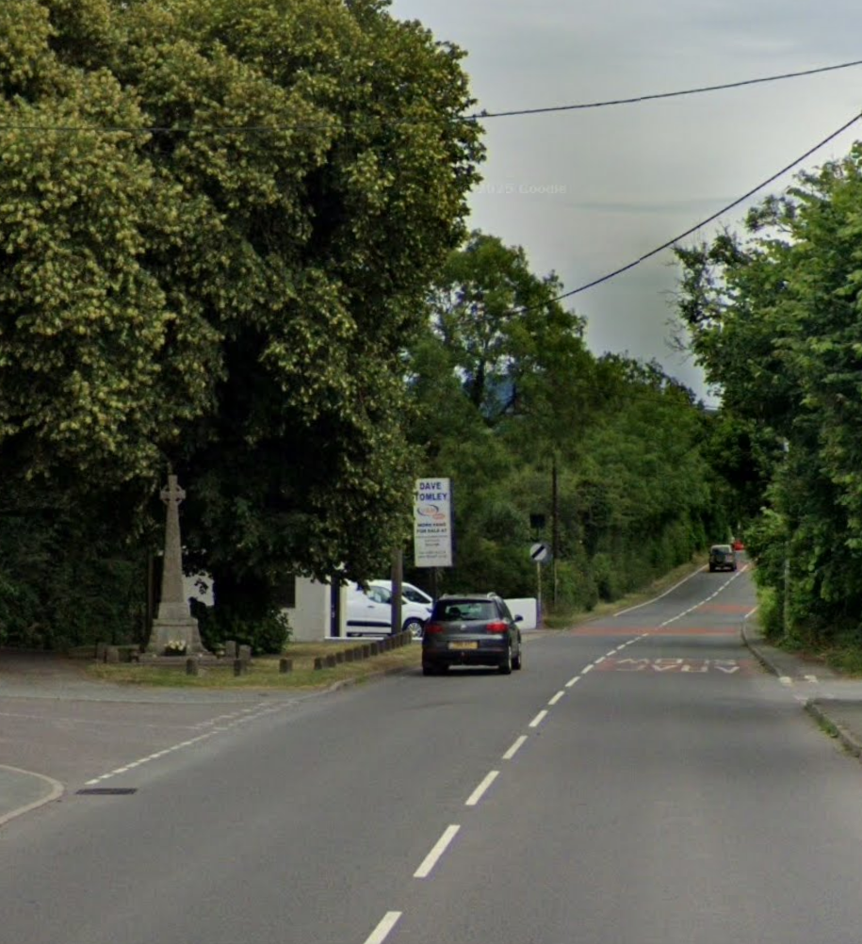

The Clerk was asked to convey this information to Ms Davies.
ACTION: Clerk

12.2. The Clerk tabled another item which had arrived that morning from Chloe Masefield,
Sustainable Food Places Coordinator - South Powys

I am the Coordinator for Bwyd Powys Food, the sustainable food partnership for Powys. We are trying to create a food map for Powys, showing the critical infrastructure available for residents across the area and identify gaps. This was an action which came out of our public engagement exercise in 2023 and is in the Powys Action Plan.

As the town and community councillors across Powys, we know you are in touch with communities and aware of the resources available in your areas. Please review the map at the link below and let us know whether there are any key things we are missing for your area.

We are looking for anything in the following categories:
Community food provision, Community growing, Local food providers, Events, Food banks, Community fridges, pay as you feel meals, Community gardens and / or orchards, Allotments, Cafe / restaurants selling local produce, markets, cooking classes, Community food share / shared meals,

Me Masefield has said that the map is open to changes on a continuous basis so if the councillors would like more time to provide updates that is fine.

Councillors were asked to send any information they have to the Clerk who will forward it to Ms Masefield.

ACTION: All then Clerk

12.3. County Cllr Arwel Jones said that, in response to a request from Llandysilio Community Council he will be providing regular updates on what he is doing at county level. He then gave a resumé of his last month’s work.

12.4. Ms Denise Canovan has asked for permission to purchase a bag of bulbs for all the planters. It was agreed that a sum of £50 be allocated. The Clerk said that any claim for reimbursement must be supported with receipts.

12.5. Cllr Fynes spoke of his experiences at the Welshpool Recycling Centre. He said that one is not allowed in if one arrives a little late even though the centre is empty of other users. Dumpy bags are not allowed and he was told that he must use half size dumpy bags. He also had to pay a fee for disposal of a small piece of felt and had to climb steps to put things in the skips but received no assistance.

County Cllr Arwel Jones said that the system was getting out of control. The scheme would be reviewed by the County Council in October. He said that an ANPR system was being installed and he felt that this should not happen until the review had taken place.

12.7 Cllr Done passed on a request from an elderly resident that the minutes posted on the Council’s noticeboard should be in large font to make them easily readable.

12.8. Cllr Done reported that the apparently abandoned car at the Dolphin car park ahs been removed. He had spoken to the Landlord at the Dolphin about the car park. The landlord has told him that the County Council had not paid the rent that it owes for the area which it leases. County Cllr Arwel Jones pointed out that Powys County Council has a 99-year lease on this site.

12.9. Cllr Done asked councillors to suggest wording for a sign to be put up at the car park at the Boundary Stone. This should be to alert users that commercial use is prohibited and that overnight parking is not allowed.
ACTION: All.

.
13. Date of the next meeting:

Tuesday 30th September 2025 at 7.00pm at Llanymynech Village Hall.
ACTION: All to note.

Approved by Council as a correct record: -

Proposed: ________________________________________________________

Seconded: ________________________________________________________

Signed: __________________________________________________________ Chairman

Date: _______________________________________________________

